1)Example 1:

#include <stdio.h>

int main() {

int i,n;

float x, sum = 0.0, term = 1.0;

printf("Enter the value of x ");

scanf("%f", &x);

printf("Enter the number of terms(n) ");

scanf("%d", &n);

sum = 1.0;

for (i = 1; i <= n; i++)

{

term \*= x;

sum += term;

}

printf("Sum of the series is: %.4f\n", sum);

return 0;

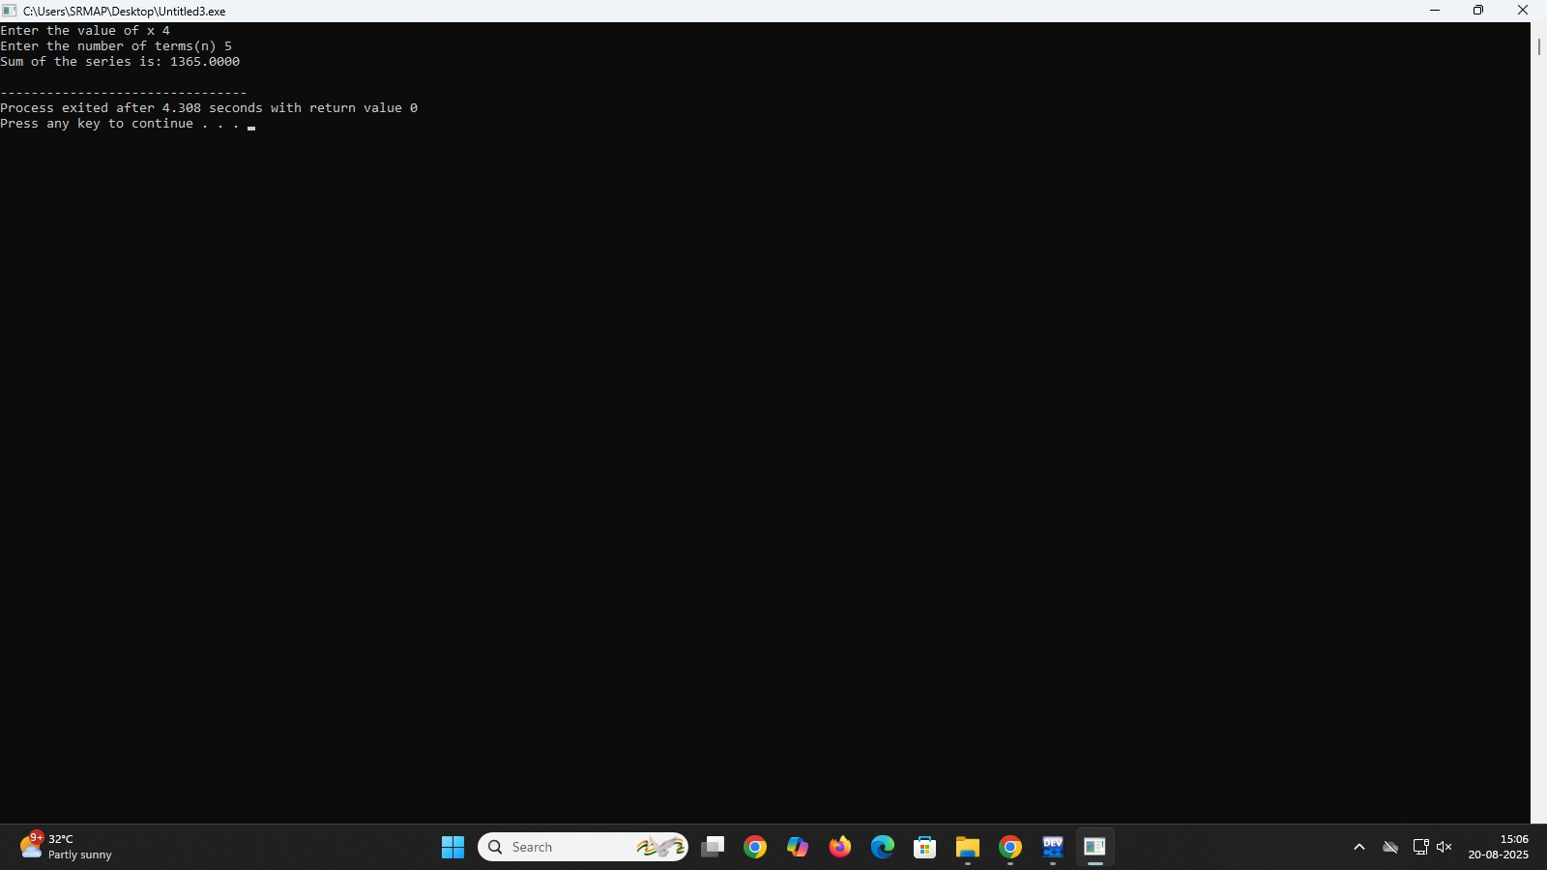}

Example 2:

#include <stdio.h>

int main()

{

int i,j,n;

float x, sum = 0.0 , term;

printf("Enter the value of x ");

scanf("%f", &x);

printf("Enter the number of terms(n) ");

scanf("%d", &n);

for (i = 0; i <= n; i++)

{

term = 1.0;

for (j = 0; j < i; j++)

{

term = term\*x;

}

sum = sum+term;

}

printf("Sum of the series is %.4f", sum);

return 0;

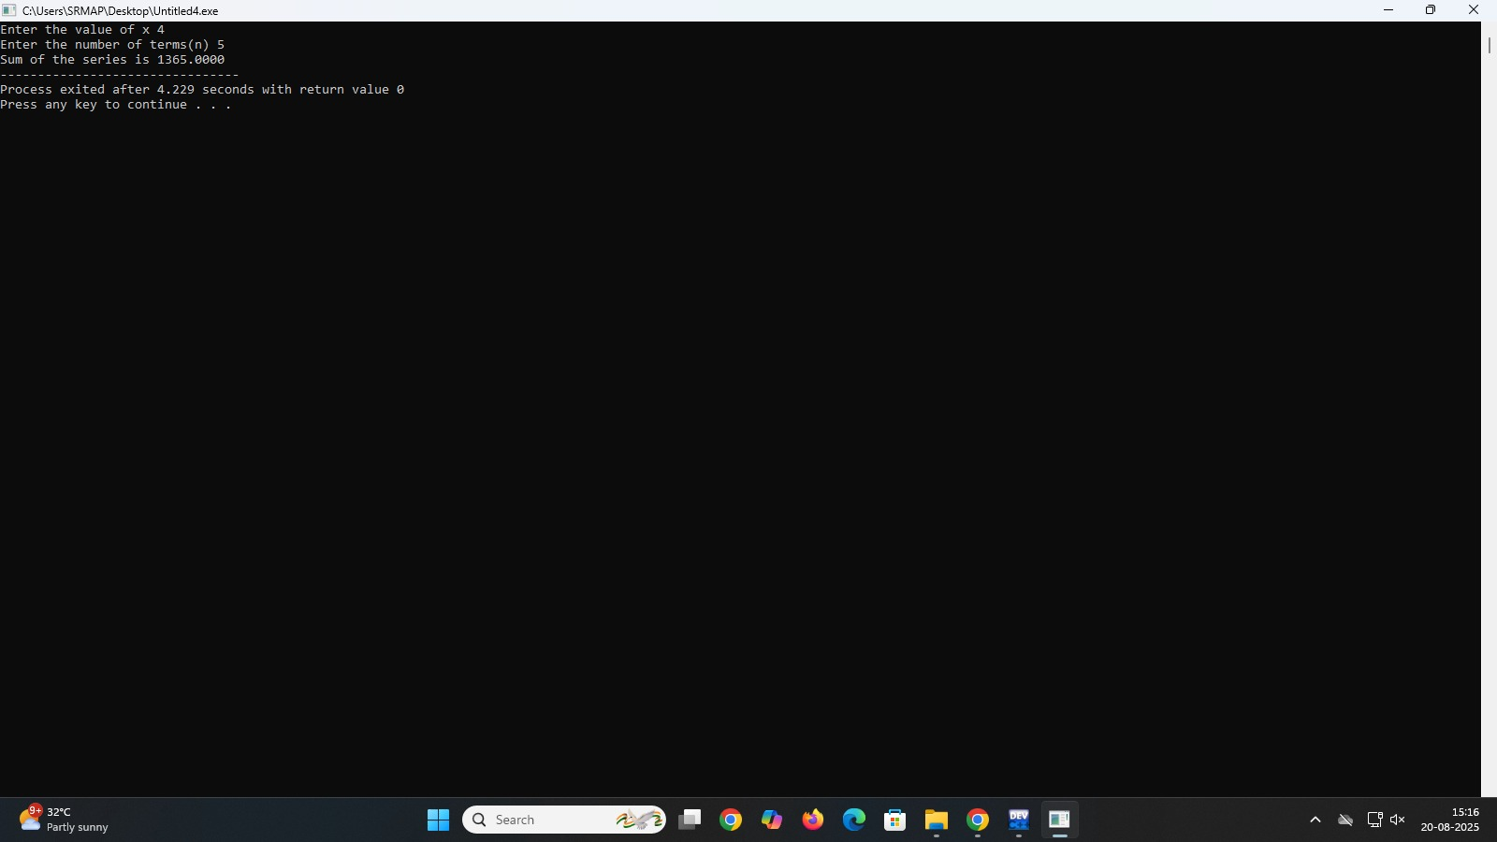}

2)

#include <stdio.h>

#include <stdlib.h>

Struct node {

Int data;

Struct node \*left, \*right;

};

Struct node\* newnode(int data)

{

Struct node\* node = (struct node\*) malloc(sizeof(struct node));

Node->data = data;

Node->left = node->right = NULL;

Return node;

}

Struct node\* insert(struct node\* root, int data)

{

If (root == NULL)

{

Return newnode(data);

}

If (data < root->data)

{

Root->left = insert(root->left, data);

}

Else if (data > root->data)

{

Root->right = insert(root->right, data);

}

Return root;

}

Struct node\* deletenode(struct node\* root, int data)

{

If (root == NULL)

{

Return NULL;

}

If (data < root->data)

{

Root->left = deletenode(root->left, data);

}

Else if (data > root->data)

{

Root->right = deletenode(root->right, data);

}

Else

{

If (root->left == NULL)

{

Struct node\* temp = root->right;

Free(root);

Return temp;

}else if (root->right == NULL)

{

Struct node\* temp = root->left;

Free(root);

Return temp;

}

Struct node\* temp = root->right;

While (temp->left != NULL)

{

Temp = temp->left;

}

Root->data = temp->data;

Root->right = deletenode(root->right, temp->data);

}

Return root;

}

Void inorder(struct node\* root) {

If (root == NULL) return;

Inorder(root->left);

Printf(“%d “, root->data);

Inorder(root->right);

}

Int main() {

Struct node\* root = NULL;

Root = insert(root, 20);

Insert(root, 50);

Insert(root, 10);

Insert(root, 40);

Insert(root, 60);

Insert(root, 30);

Insert(root, 70);

Printf(“ Before deletion: “);

Inorder(root);

Printf(“\n”);

Root = deletenode(root, 40);

Root = deletenode(root, 30);

Printf(“After deletion: “);

Inorder(root);

Printf(“\n”);

Return 0;

}

